Vendoring
Vendor edit:
From the Main Menu under Lookup and Maintenance click on Vendor
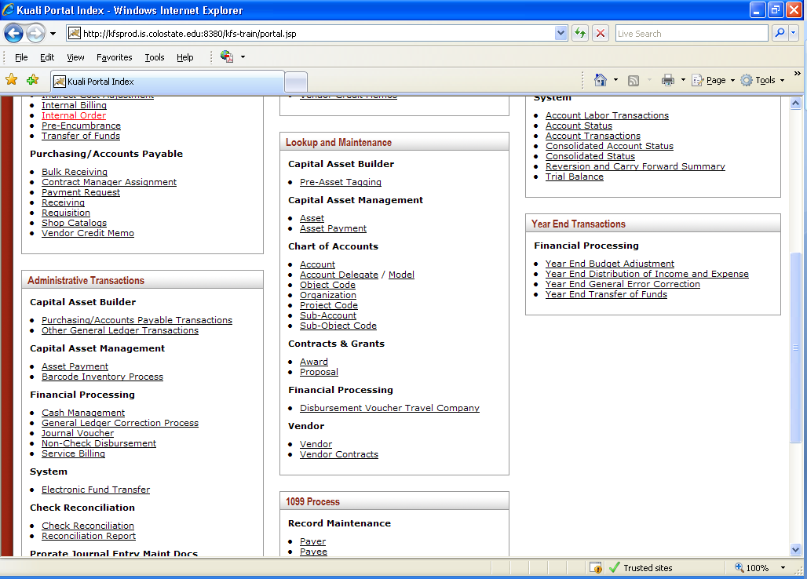
That will bring you to the below screen - Input all or part of the vendor name and click search
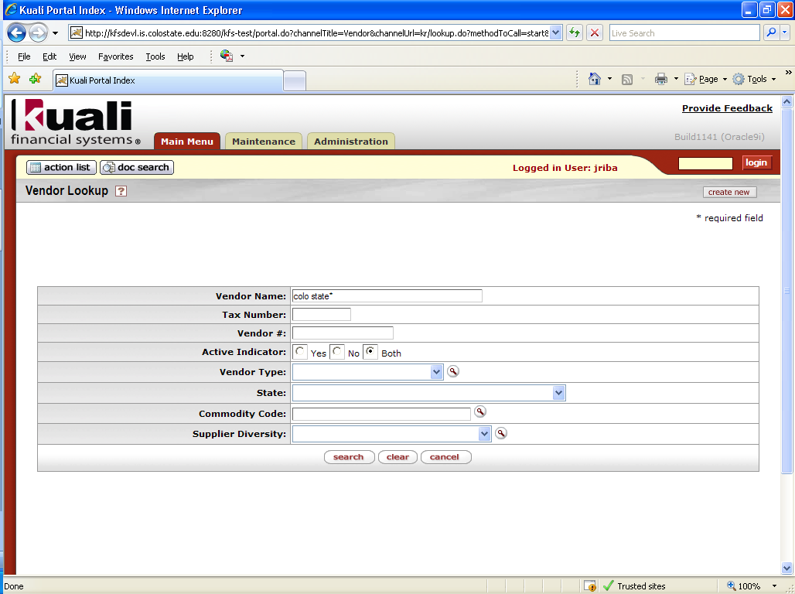
Input all or part of the vendor name and click search.
Scroll down until you find your vendor
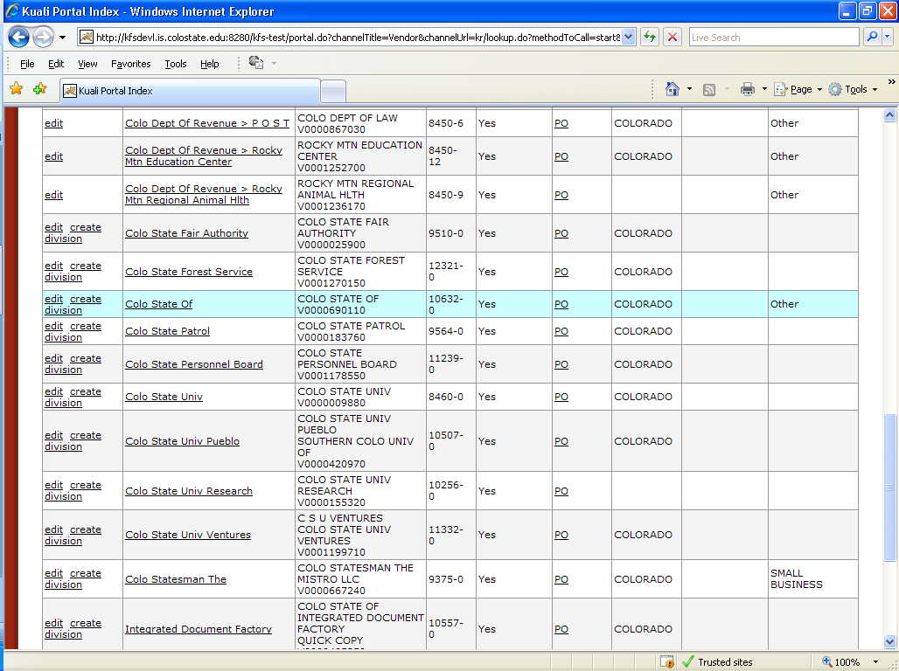
Click on vendor name to view all addresses associated with this vendor. Scroll down to find your address. If your address is not there you will need to edit the vendor to add the new address field under address. Be sure to input a description in the description field under Document Overview. Please do not change the set as default address unless instructed to do so by Purchasing or Accounts Payable.
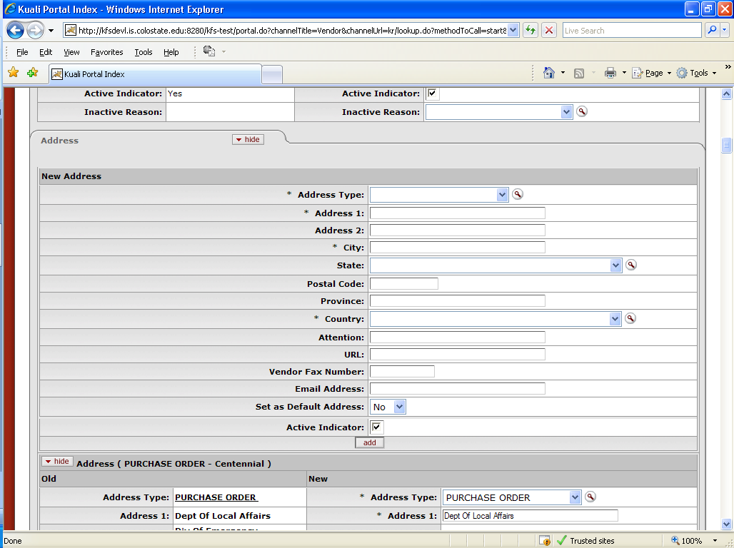

Select address type (Remit) Choose Remit from the drop down menu. Input your address, city, state, postal code, and country. Click add.

Your new address will be moved to the bottom of the addresses and look like this
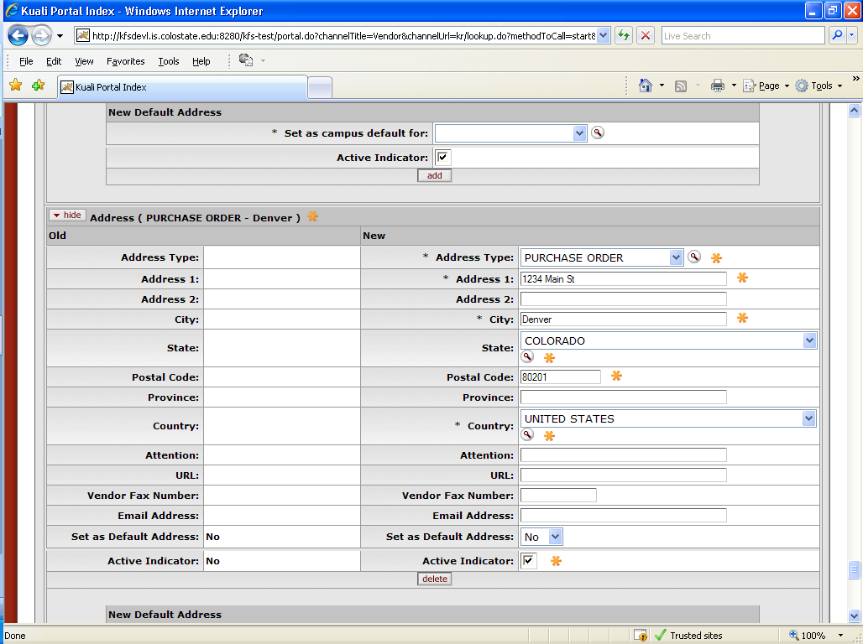
Add backup in the notes and attachment section so changes can be verified.
Click submit button. If all went well you will get document was successfully submitted message. Once your new address has been approved by Accounts Payable you will get an FYI notification.

Vendor create:

From the Main Menu under Lookup and Maintenance click on Vendor

Click on Create new
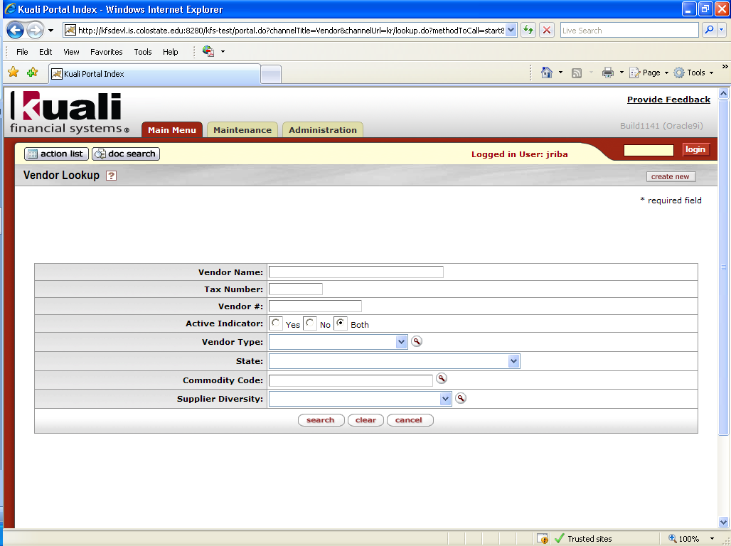
That opens a brand new Vendor document in Kuali.
The tabs you will need to complete will be Document Overview, Vendor, Address and Notes and Attachments. All tabs will be opened when you are brought back to this screen.
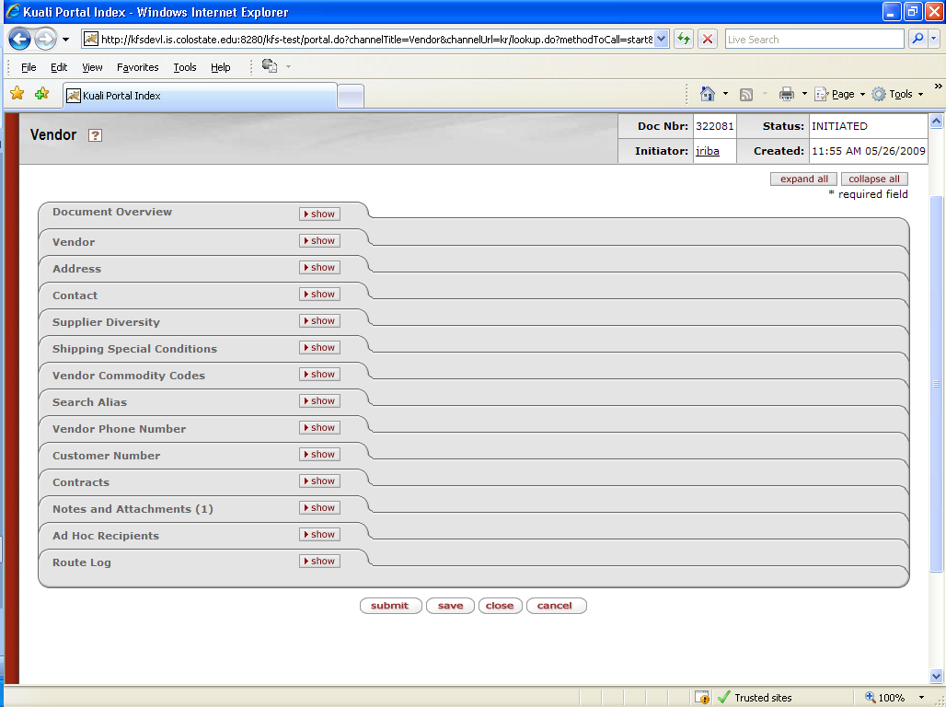

As with all documents in KFS – Input a description in Document Overview – New Vendor – and vendor name

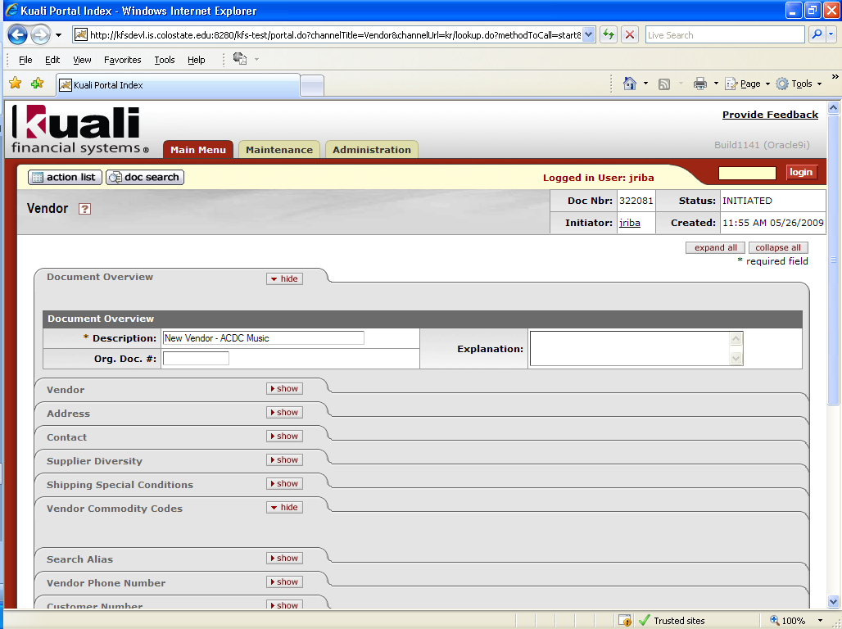
Under Vendor tab Complete:
New - The Vendor Name
Corporate Information - Vendor Type (Purchase Order)
Ownership Type: Must match the W-9 ownership type
Input the tax number from the W-9
Change W9 Received to yes
Add date W9 was signed
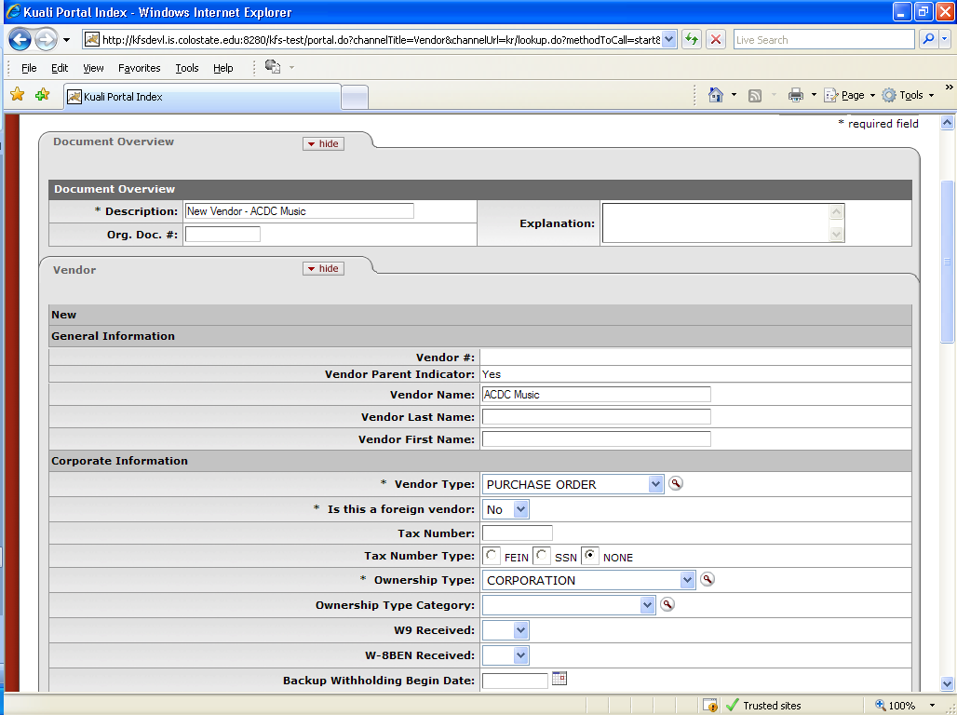

Under the Address tab – complete New Address
Address Type – Purchase Order
Address, City, State, Postal Code, Country
Add Vendor Fax Number. The fax numbers or email address must be added to insure Purchasing is able to distribute the PO to the vendor.
Change - Set as Default Address from No to Yes
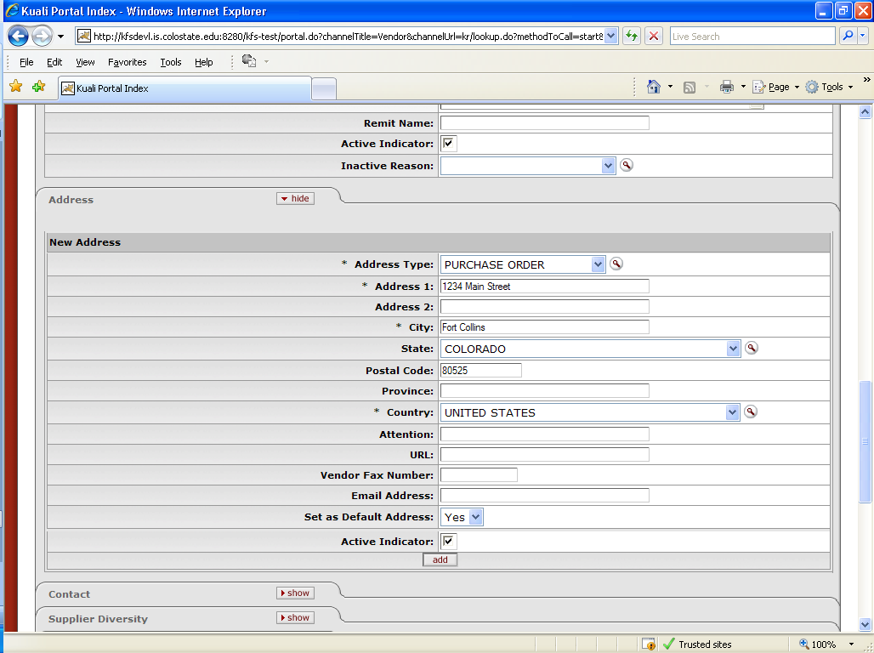
Click Add

In the notes and attachment section add the W9 and copy of invoice if you have one.

Click submit button. If all went well you will get document was successfully submitted message. Once your new address has been approved by Accounts Payable you will get an FYI notification if you open the document you will see the new vendor number.

Vendor Create – Individual:
As with all documents in KFS – Input a description – New Vendor – and vendor name
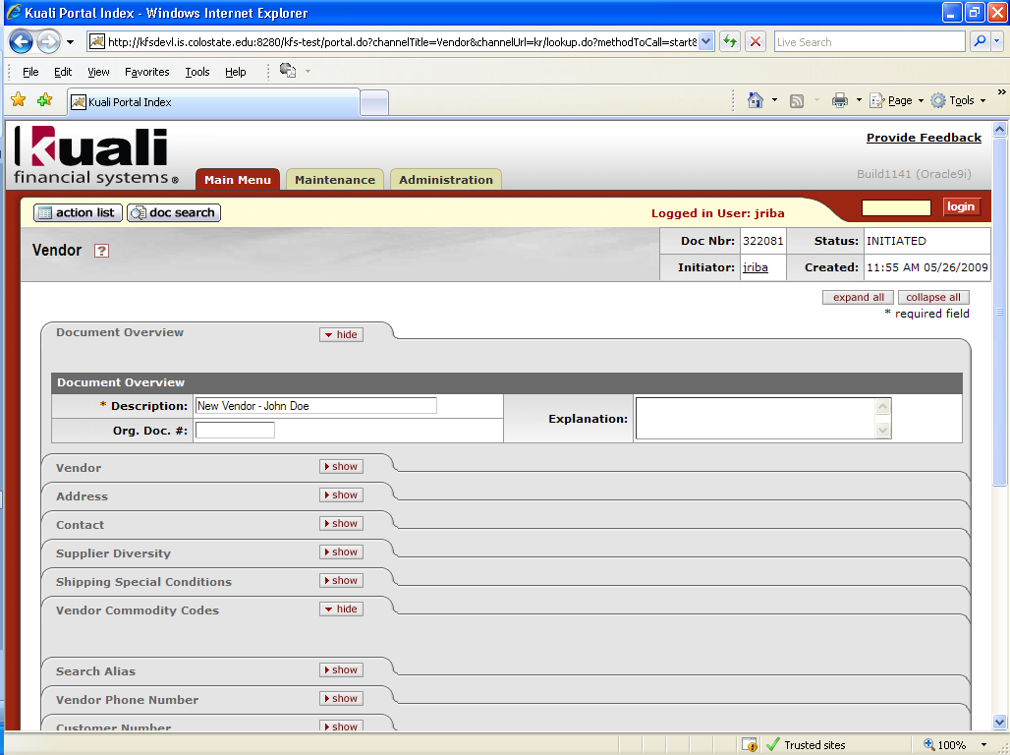
Under Vendor tab Complete:
New – Vendor Name: First name space Last name. Do not use Vendor Last Name/Vendor First Name
Corporate Information - Vendor Type (Purchase Order)
Tax number social security number from W9
Tax number type-SSN
Ownership Type: Individual/Sole Proprietor
W9 Received – yes
Date W9 signed
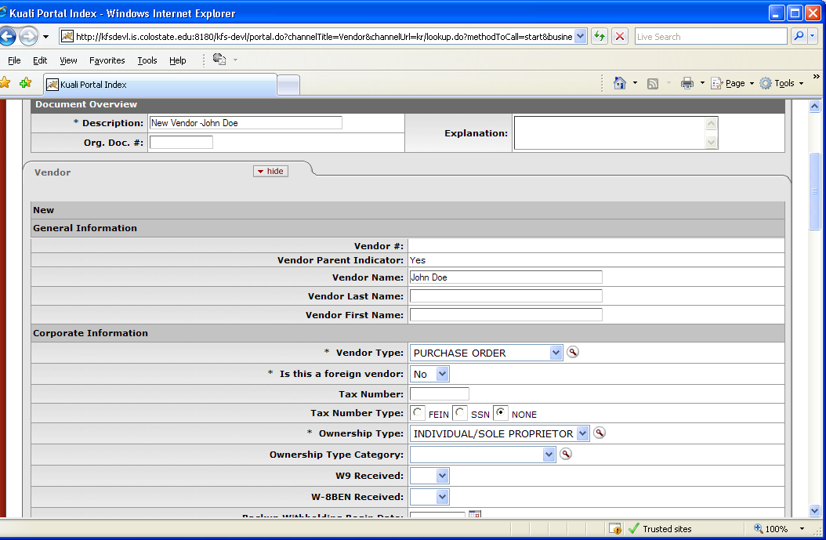

Under the Address tab – complete New Address
Address Type – Purchase Order
Address, City, State, Postal Code, Country
Change - Set as Default Address from No to Yes
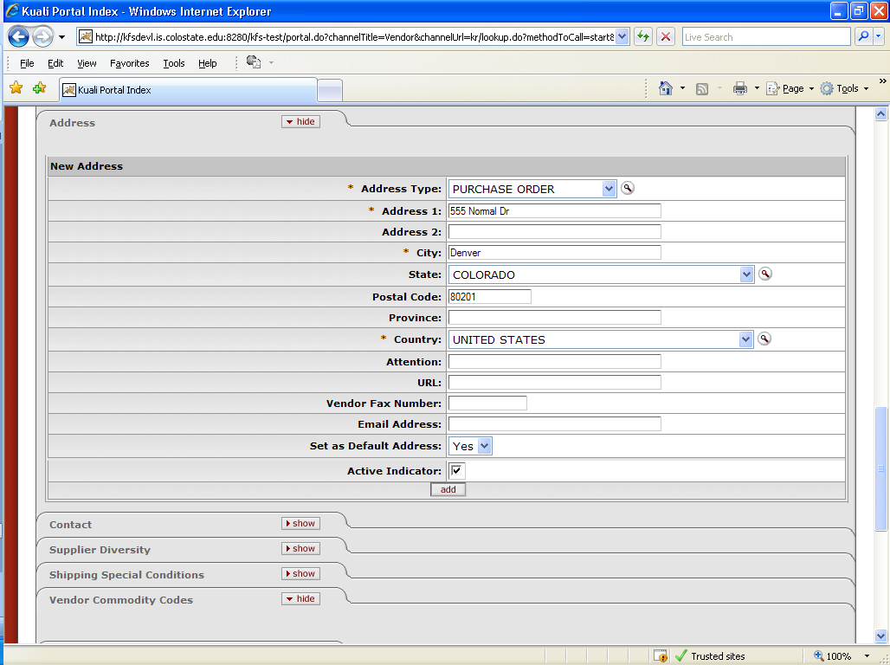
Click Add.
Go to notes and attachments tab and attach the W-9 and any other backup.
Click submit button. If all went well you will get document was successfully submitted message. Once your new address has been approved by Accounts Payable you will get an FYI notification if you open the document you will see the new vendor number.

